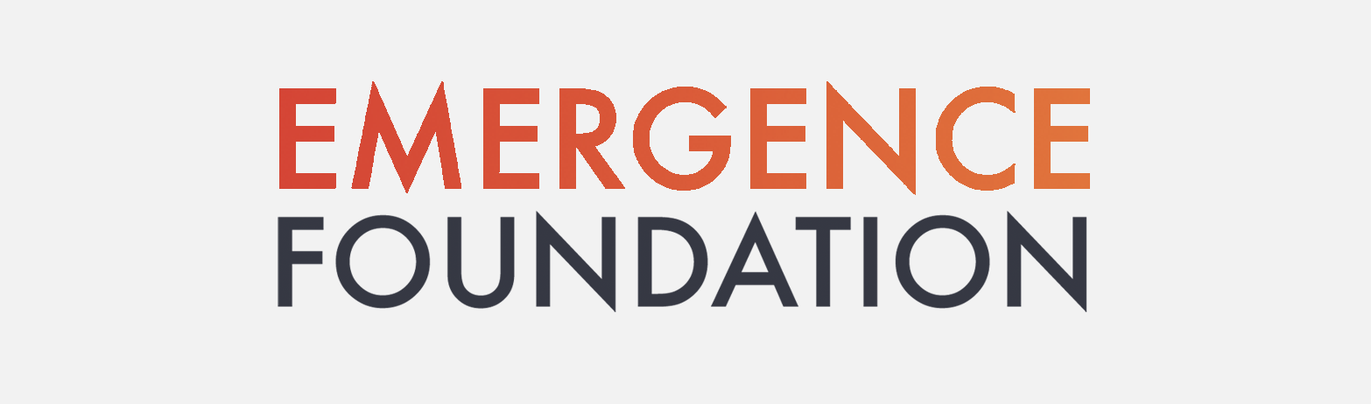

VIDEO GUIDANCE

NB Videos should only be submitted as part of a Full Application. Please do not submit them at the EOI stage as we won’t be able to do anything with them until later.

INTRODUCTION
When applying you have the option of submitting a short (up to 3 minutes) video in support of your Full Application.

This video will be available to EF Stakeholders to view, prior to them voting on projects that
they want to support. The Stakeholder vote, along with the assessment of the written application, are important factors considered by the Grants Panel at their meeting. Grants Panel members also see the videos.

Your video may help our Stakeholders to appreciate the nature of your scheme, the passion and commitment that you/your organisation have. It may be a useful adjunct to your written application in providing additional information to Stakeholders.

Please note that the submission of a video is entirely optional. If you do not want to or are not able to submit a video this will not disadvantage you in the paper assessment.

NATURE OF CONTENT
We very much encourage you to make your video however you feel is right for you. You might, though, want to consider some of the points we’ve included below. It’s worth adding that the Stakeholders do not see your Full Application form (for a variety of reasons including Data Protection) but will see a precis of it. It may help them, therefore, if you cover some of these aspects:

- The aims/purpose of your project
- The needs your project addresses and the extent of demand for them
- Details of beneficiaries (in general terms, not names) – individuals and/or communities
- How they will benefit from your project
- Your experience and qualifications, where relevant and appropriate, (or those of the people delivering the scheme)
- Aspects of quality (e.g. standards; experience/qualifications of facilitators)

Other points
- Your passion, commitment and motivation
- Anything that you couldn’t include in your application but wanted to say
- If your project does not easily fit into the project categories in the Guidance then you may want to say more about how it delivers on our aims.
Once again we’d like to emphasise that the above are just some ideas to consider.

ABOUT QUALITY...
There’s no need to be overly concerned about creating something with high production values. Our Stakeholders’ primary interest will be in the content and how you’re delivering our aims.

DATA PROTECTION
Apart from the name of your organisation or yourself (if you’re an individual applicant) do not include any personal names, addresses and phone numbers in your video. This is due to protection of data laws which we have to take very seriously. We won’t be able to approve for viewing any video that incorporates the names, addresses or location of third-party individuals. You can, of course, identify other people speaking in your video. You can also use the name of another organisation so long as no individual names or addresses are given.

BEHAVIOUR AND LANGUAGE...
Naturally, it’s very important that the style, behaviour and language in your video is fully appropriate and best reflects your application. We would not be able to put up anything we perceive as at all offensive or that could be seen as slanderous.

VIDEO REQUIREMENTS
Max length 3min
File format .m4v, .mp4, .mov
Max file size 60MB

If your video file does not meet our upload requirements, you would need to convert it. Prism is one example of a software you can use http://www.nchsoftware.com/prism. In order to downsize the file you might have to change the compression format to mpeg4 and resize the video to a max-width of 768px with a preferred aspect ratio of 16:9.

NAMING YOUR VIDEO
Please make sure the name of the file you upload has your organisation’s name clearly in the title or, if applying as an individual, your own name so that we can clearly identify it! Also ensure you have completed the question about video upload on the Full Application form.

SENDING/UPLOADING VIDEOS
Videos should be uploaded via https://emergencefoundation.uk/videoupload Please do not send them to our email addresses as they are likely to be far too large!

DEADLINE/CLOSING DATE
The deadline for uploading your video is the same as the closing date for your Full Application.

ANY PROBLEMS?

If you have any questions or problems we will be happy to try and help if you contact us at:

Email: grantenquiries@emergencefoundation.uk

Telephone: 07889 234340

